Practice 3

**Part 1**

1. Write a query to display the current date. Label the column Date.



1. The HR department needs a report to display the employee number, last name, salary, and salary increased by 15.5% (expressed as a whole number) for each employee. Label the column New Salary. Place your SQL statement in a text file named lab_03_02.sql.
2. Run your query in the lab_03_02.sql file.

# …

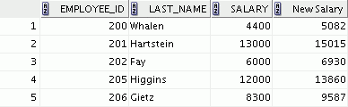

1. Modify your lab_03_02.sql query to add a column that subtracts the old salary from the new salary. Label the column Increase. Save the contents of the file as lab_03_04.sql. Run the revised query.

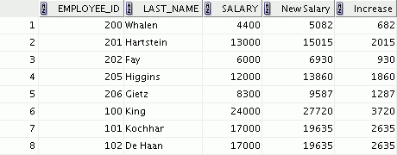

**…**



1. Write a query that displays the last name (with the first letter uppercase and all other letters lowercase) and the length of the last name for all employees whose name starts with the letters *J, A,* or *M*. Give each column an appropriate label. Sort the results by the last names of the employees.

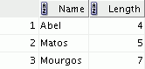

Rewrite the query so that the user is prompted to enter a letter that starts the last name. For example, if the user enters H when prompted for a letter, the output should show all employees whose last name starts with the letter *H*.

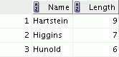

1. The HR department wants to find the duration of employment for each employee. For each employee, display the last name and calculate the number of months between today and the date on which the employee was hired. Label the column MONTHS_WORKED. Order your results by the number of months employed. Round the number of months up to the closest whole number. **Note:** Your results will differ.

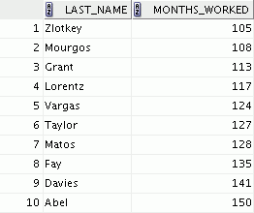

**…**



Part 2

1. Create a report that produces the following for each employee:

<employee last name> earns <salary> monthly but wants <3 times salary>. Label the column Dream Salaries.

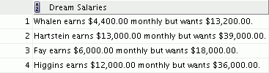

**…**

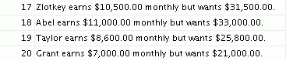

If you have time, complete the following exercises:

1. Create a query to display the last name and salary for all employees. Format the salary to be 15 characters long, left-padded with the $ symbol. Label the column SALARY.

# …

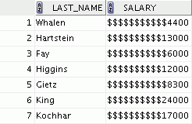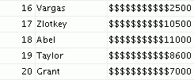

1. Display each employee’s last name, hire date, and salary review date, which is the first Monday after six months of service. Label the column REVIEW. Format the dates to appear in the format similar to “Monday, the Thirty-First of July, 2000.”

# …

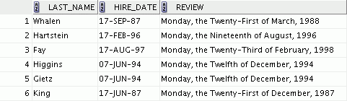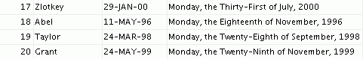

1. Display the last name, hire date, and day of the week on which an employee started. Label the column DAY. Order the results by the day of the week, starting with Monday.

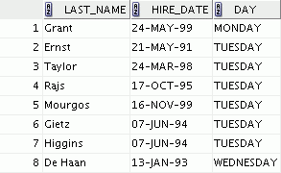

**…**

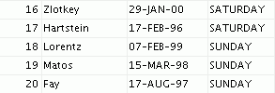

If you want an extra challenge, complete the following exercises:

1. Create a query that displays the employees’ last names and commission amounts. If an employee does not earn a commission, show “No Commission.” Label the column COMM.

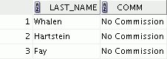

**…**

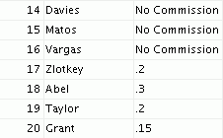

1. Using the DECODE function, write a query that displays the grade of all employees based on the value of the JOB_ID column, using the following data:

***Job Grade***

AD_PRES A

ST_MAN B

IT_PROG C

SA_REP D

ST_CLERK E

None of the above 0

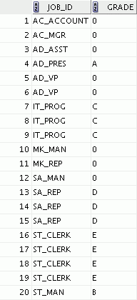

Rewrite the statement in the preceding exercise using the CASE syntax